Industrial visit at SOBISCO, 27th September 2019.
REPORT:
Department of Food processing organized a one day Industrial visit at SOBISCO, Sawraphuli, Hoogly on 27th September 2019. Total 33 students (male-64 and female-38) with 5 faculty members (Male: 03 and Female: 02) participated in this visit. Industrial visits provide the students with an opportunity to learn practically through interaction, working methods and employment practices. It gives the students an exposure to current work practices as opposed to theoretical knowledge being taught at their college classrooms. The students are very much interested and motivated by observing the food industry. They requested our department to organize that type of industry visit in every year.
PHOTOS:
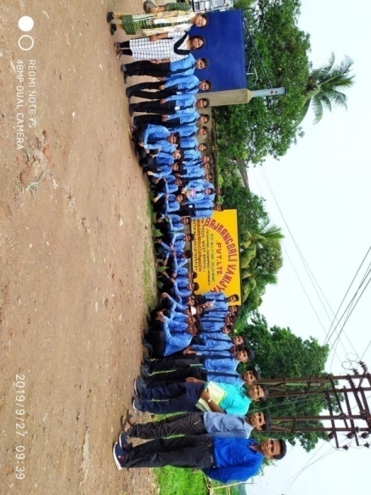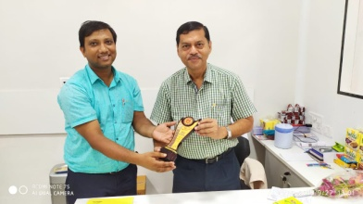
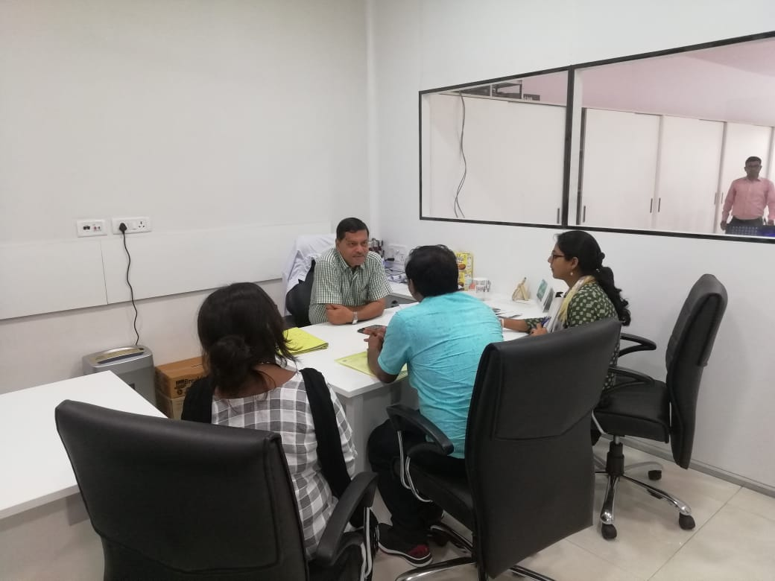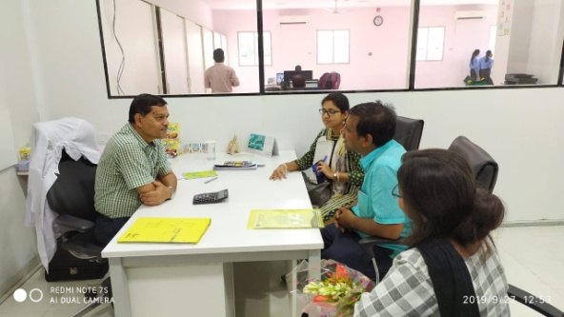
Attendance of Participants:

- Apurba Giri
- Tanmoy Giri
- Prabir Jana
- Monalisa Roy
- Suchata sahoo
- Buddhadev Jana
- Buddhadev Mistri
- Debdulal Sahoo
- Koushik Mandal
- Madhumanti Pradhan
- Mahasewta Maity
- Prabin Nayak
- Puja Bhunia
- Rakhi Rani Guria
- Ranajit Maity
- Sanjib Das
- Saswati Jana
- Shyam Sundar Gole
- Somashree Patra
- Subha Das
- Sudipta Bera
- Sujata Sasmal
- Sagar Maity
- Nilima Maity
- Sukhendu Bera
- Chiranjit Pal
- Sourav Mistri
- Sougata Acharya
- Surja Kanta Das
- Sumit Patra
- Sukhendu Das
- Prasenjit Pal
- Subhamay Jana
- Pralay Das
- Suman Jana
- Subhajit Paria
- Subrata Ghosh
- Debabrata Pradhan
- Mrinal Kanti Bera

FEEDBACK:
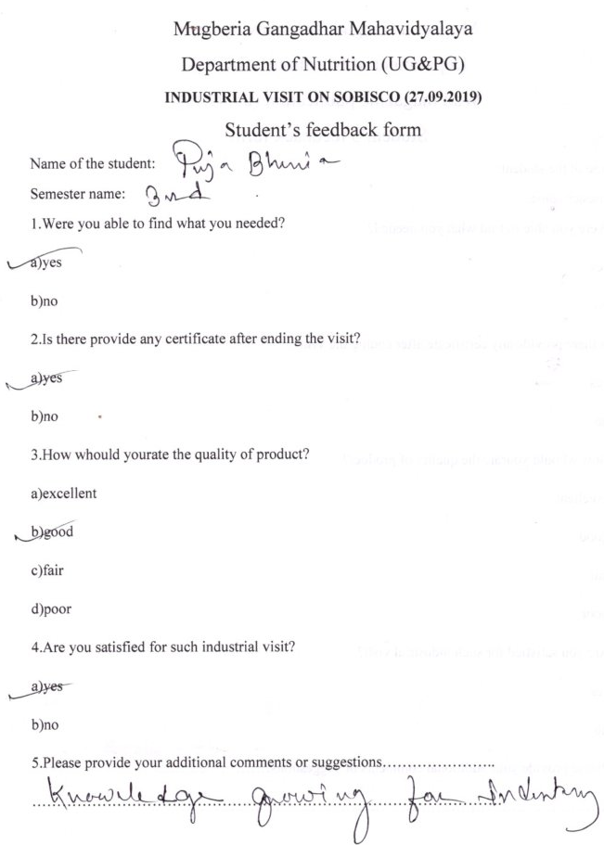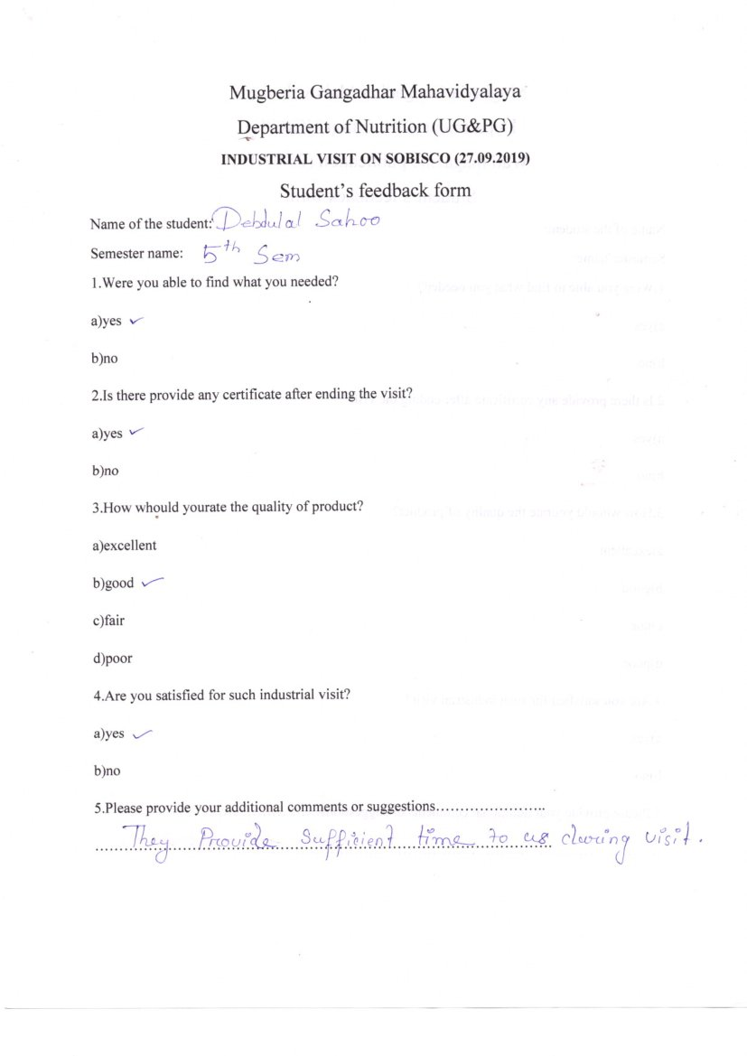

RESOLUTION:
1. Industrial visit is the first point of contact of a student towards the corporal world.
2. The domain wisdom and practical outlook towards the industry & requisite skills for the industry is also known to the students.
3. It help students gain first hand information regarding functioning of the industry.
4. Provides opportunities to plan organize and engage in active learning experiences both inside and outside the classroom.
5. It is mandatory full fills certain curriculum requirements.

